**CHAPTER FOUR**

**SYSTEMS IMPLEMENTATION**

**4.1 Hardware Requirement**

The following is the list of the features of the PC that was used in the implementation of the online court case filing system. All of the software used in implementation were downloaded and duly installed. To be more specific, an HP 630 Laptop with the following specifications was used for the implementation of the online court case filing System project work;

* A 64-bit Operating System (Windows 7)
* 4 Gigahertz Processor Speed (Intel Pentium Dual Core)
* 500 Gigabytes Hard disk
* 4 Gigabytes RAM (Random Access Memory).

The installation processes of the necessary software that used were done step by step on the system, following the prompts displayed by the application setups until installations were fully completed.

**4.2 Installation Procedure**

The following are the tools that were used in the process of building (design and implementation of the online court case filing System:

* PHP Storm IDE
* Adobe Photoshop CS6 (Creative Suite 6)
* Notepad++
* XAMPP Server

**4.1.1 PHP Storm Integrated Development Environment (IDE)**

PHP Storm was used in writing the PHP scripts of this project work. Its advantage over using any other tool in writing PHP scripts is the powerful intelligence in text auto-completion in predicting PHP keywords (*intellisense*), reserved words, variables defined, methods defined, function defined and classes created. All these important features made the coding part of the implementation easier. Figure 4.1 on the next page shows the code window of the PhpStorm IDE during the implementation of the Online Court case filing System project work.

**4.1.2 Adobe Photoshop**

Adobe Photoshop, or so-called "PS", is a graphics editing program developed and published by Adobe Systems. Adobe Photoshop CS6 (Creative Suite 6) was used in the design of graphical items used in the implementation of the online court case filing system project work. It was used to create and edit pictures, create the web layouts. Upon loading Photoshop, a sidebar with a variety of tools with multiple image-editing functions appears to the left of the screen. These tools typically fall under the categories of drawing, painting, measuring and navigation, selection, typing, and lastly retouching. All of these were used in the creations of banners and editing of pictures. After the design of the online court case filing system project work layout on Photoshop (CS6) was done, the rendering (coding) was then done using HTML and CSS on notepad. The adobe Photoshop was used for the design of slide image used on the home page of the online Court case filing system.

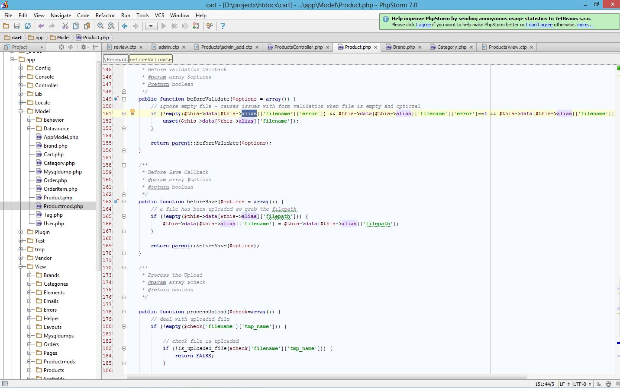

Figure 4.1 PhpStorm IDE showing the online court case filing system project source code

**4.1.3 Notepad++**

Notepad++ is a text editor and source code editor for Windows. It is a lightweight application used in writing different programming and mark-up languages. Notepad++ was used in this project for writing the HTML and CSS of the project. A snapshot of Notepad ++ code window (the application controller script) is shown in figure 4.3. Notepad ++ was also used during the modular debugging of the web app, any faulty module (script) of the project can be seen and edited just by opening it with notepad ++.

**4.1.4 Extensible Apache, MySQL, PHP** **and Perl (XAMPP) Server**

XAMPP server is a free and open source cross-platform web server solution stack package, consisting mainly of the Apache HTTP Server, MySQL database, and interpreters for scripts written in the PHP and Perl programming languages. It is the development tool used to test the project work on personal computers without any access to the Internet. XAMPP Server gave the access to phpmyAdmin on the web browser.

Once XAMPP was installed, it was used to treat the localhost PC like a remote host by connecting using an FTP (File Transfer Protocol) client. Apache 2.4.9, MySQL 5.6.16, PHP 5.5.11, phpMyAdmin 4.1.12, FileZilla FTP Server 0.9.41, Tomcat 7.0.42 (with mod_proxy_ajp as connector), Strawberry Perl 5.16.3.1 Portable, XAMPP and Control Panel 3.2.1 (from hackattack142) are the components in the latest XAMPP server (version 7.5.2 of XAMPP for Windows with control panel version 3.2.2) as shown in figure 4.4 was used for the implementation of the online court case filing system. For the web browser used to access the local host to open the online court case filing court case filing, the project folder must be copied in to the htdocs folder of the XAMPP server in the hard drive of the PC. Also Apache, MySQL and Filezilla must be started on the XAMPP Server control panel as shown in figure 4.4.

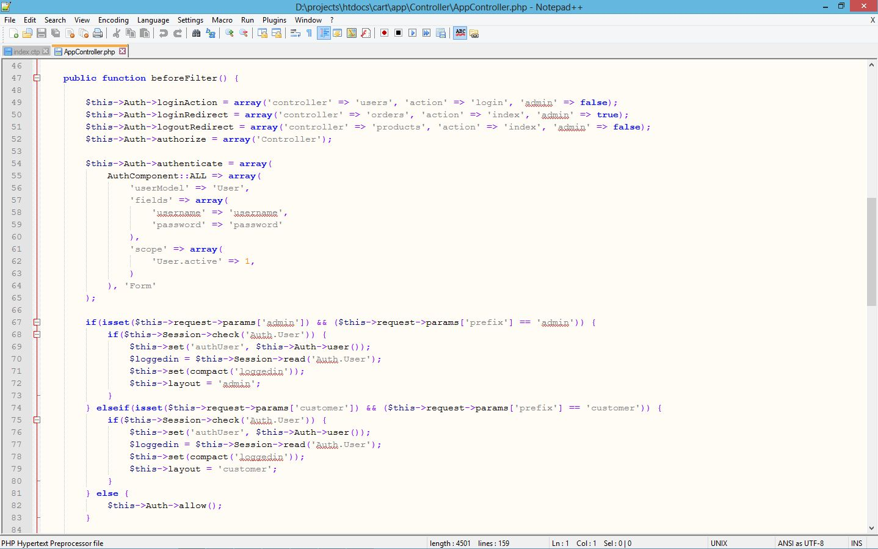

Figure 4.3 Notepad ++ Code window showing the app controller script of the project

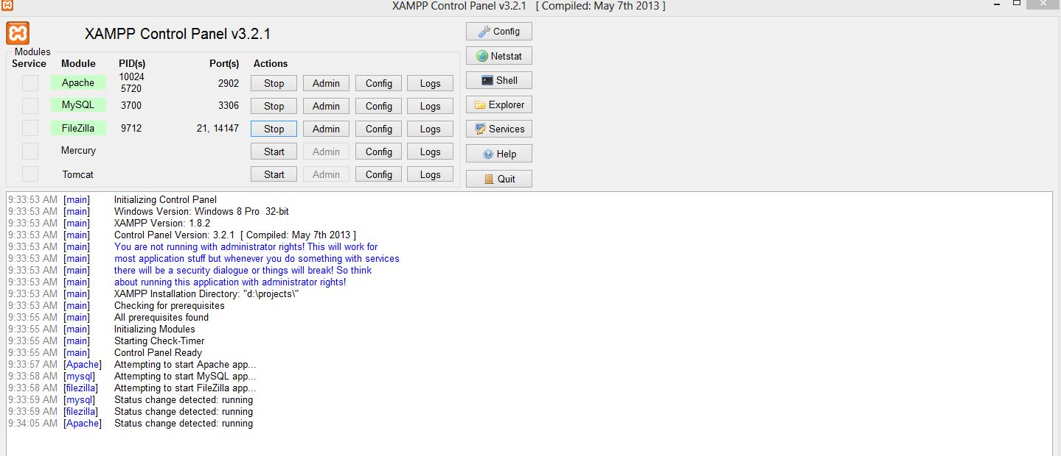

Figure 4.4 XAMPP Server Control Panel

**4.3 How the Web Application Works**

The web application is hosted on the localhost (PC) using phpmyadmin, and can be accessed via http://localhost:8000, which specifies the location of the project folder; copied into the htdocs folder of XAMPP sever in the localhost. The index page for the online application is the user (plaintiff or the lawyer) login page. Registered plaintiffs are to login with username and password. For the first time plaintiffs, the user is to register on the platform, the username is their active email address and password to be used is the one they have chosen to easily remember, which must have been added into the database during registration, the plaintiff is expected to use the password for subsequent logins, while the username remains the email address. Users can reset their password in case the forget it and need to choose another one. The admin signs up using the admin link <http://localhost:8000/admin/signup>. The admin is expected to supply valid names, usernames and password which will be used to login to the admin page of the web app. This platform supports multiple admins, meaning more than one admin can login at the same time without any problem, for this to happen, the system has to be hosted online or the local host be made server in a local/intra network. The admin home page as shown allows an admin to approve or reject the filed court case.

The plaintiff or his lawyer registers on the website by producing the following specific details; legal name, current address, telephone number and valid e-mail address. The user (plaintiff or his lawyer) can then submit as many forms as possible on the created account by providing the following data; plaintiffs name, defendant name and caption describing in details the case being filed with accurately explained provable happenstances in a form of court statement. Then the user waits for the case to be approved or declined by the person in charge of court cases, in this web app, the admin. The admin’s main job is to either approve or decline a case filed. When approving a case, the admin must provide the following data relating to the case to be approved or declined for filing; Case number, case date and Court date. The admin also has the privilege to view all the users on the platform as well as their filed cases. All these are shown in following figures 4.5 to 4.9

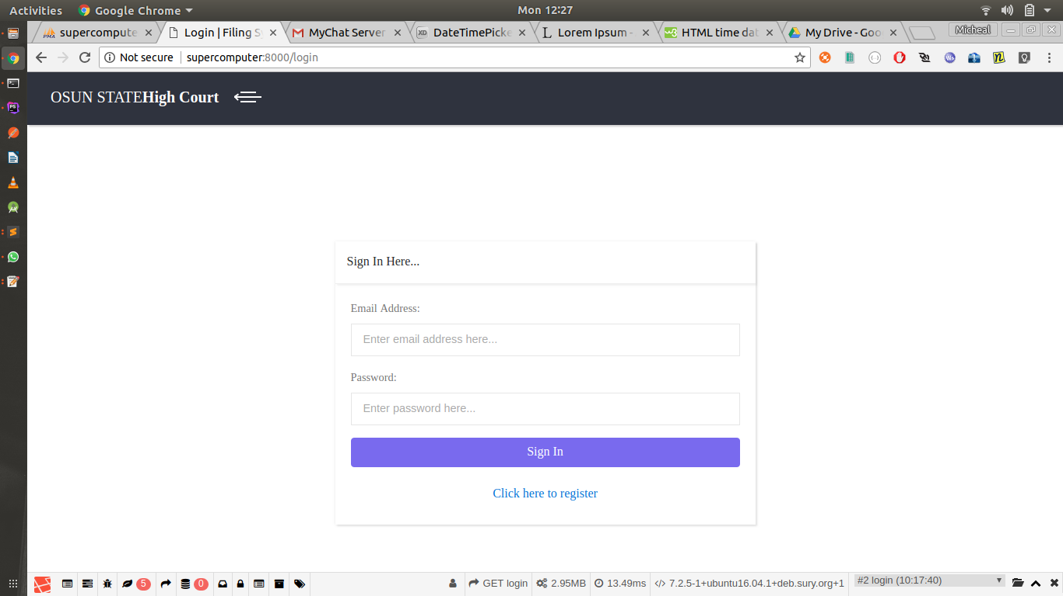

Figure 4.5 The signin/signup page

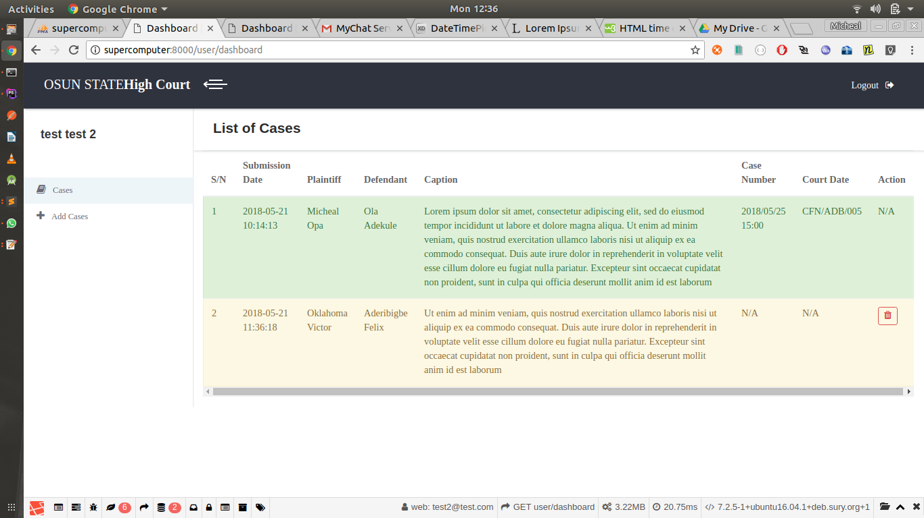

Figure 4.6 Plaintiff case filing page showing all cases filed by a user (lawyer)

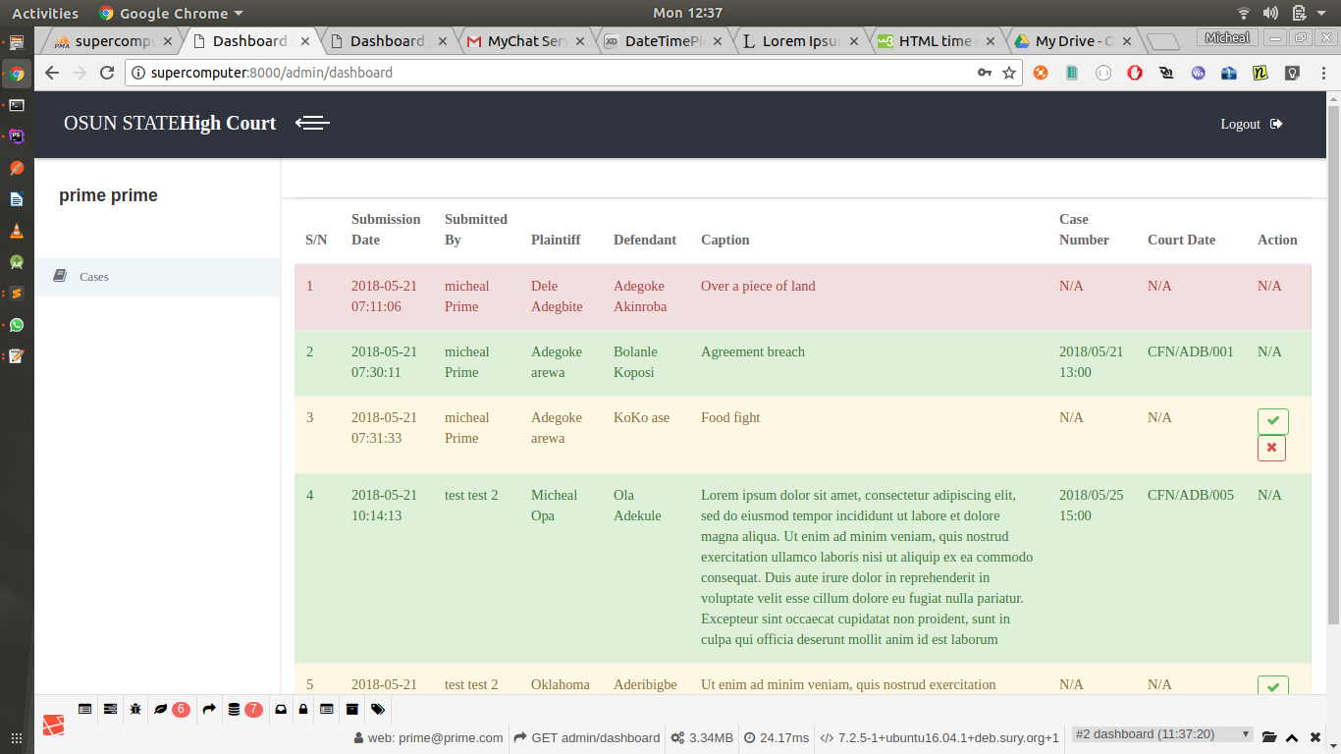

Figure 4.7 Admin page showing all filed cases

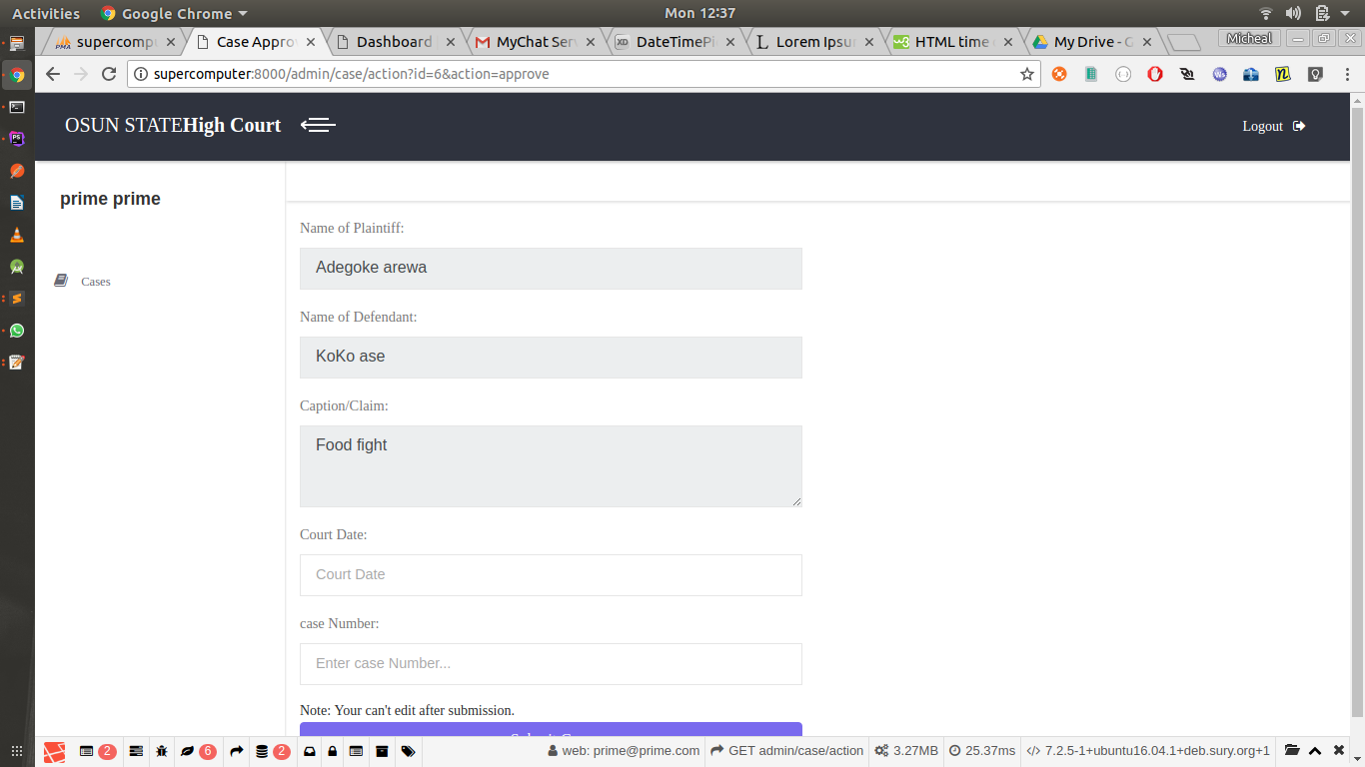

Figure 4.8 Admin viewing a filed case

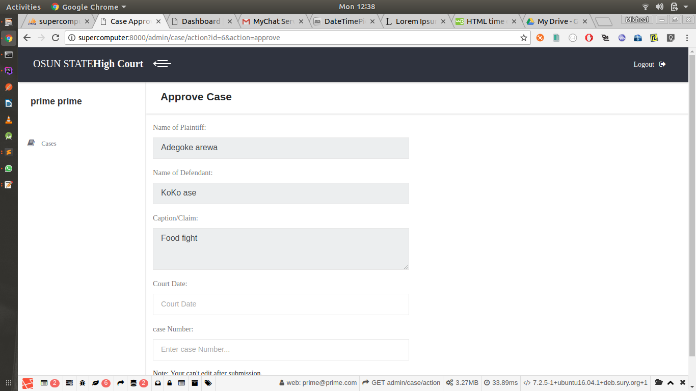

Figure 4.9 Admin approving a filed case

**4.4 Sytem Testing**

The online court case filing system was duly tested and certified working perfectly, no error report was given on any page of the web application The system consist of web pages stylishly linked together to deliver a good market experience to users, it opens well on virtually all web browsers. All links were tested and certified okay, making sure none is broken, the system was also tested on various personal computers, other than the one used for its implantation. The developed system was tested over and over, and every bug detected was corrected over and over until the system worked perfectly.

**4.4.1 Testing Plan**

Testing is one of the most important part of a software development life cycle. There are different ways of approaching an application to test. The items listed below will focus on identifying the scope of testing this court case filing system.

* Items / functionality to be tested
* Identifying users roles and responsibilities
* Define the Entry and Exit Criteria for each phase of testing
* Test Environment-Hardware / Software

The testing scope includes development and execution of the test suit consisting of the test scenarios for Unit Testing, Integration Testing, and System Testing features. They are as follows:

* Unit Testing needs done at the development stage
* Test execution carried out mostly through manual approach

**4.4.2 Test Approach**

The different levels of testing that are carried out during the Test Execution are shown below in Table 4.1

Table 4.1 levels of testing

|  |  |  |  |
| --- | --- | --- | --- |
| **Test Types** | **TestLevels**  **(Risk Level)** | **Strategy / Methods** | **Techniques for identification of test cases** |
| Unit Testing | Low | Black Box Testing | Basic function testing. |
| UI / Usability Testing | White | White Box Testing | Basic ease-of-use and function testing. |
| Functionality Testing | High | Black Box Testing | Test scenario shall be identified and based on that test cases shall be developed. |
| Usability Testing | High | Black Box Testing | Specify the functional areas to regression needed. |
| Data Integrity | High | Database Testing | This will validated by using a set of database scenarios with set of database scenario with set of available or prepared data. |

**4.4.3 Entry Criteria**

The following conditions are met for test plan entry criteria:

* All functionality described in requirement specification has been implemented
* All unit and Integration Test cases have been successfully executed
* Test environment includes test database with the master data operations as accessible via localhost/phpmyadmin/courtcasedb

The web app on the other hand is first run on the local host using chrome browser. However a local host is good for checking functionality but for tests on usability and real-time tests, the website is expected to be hosted.

**4.4.4 Setting up the Test Environment (Installing the App)**

The native app when compiled has the file format "apk". The file must be transferred to the mobile device first and installed. This is done via USB. But since android does not allow to installation of non-market apps by default, the option has to be set to allow it for that. Once this is done, dummy trial accounts are created for testing.

**4.4.5 Testing Methods Overview**

**4.4.5.1 Functional Testing**

Here the basic functionality of the web app is tested first one at a time individually then after integrating it with other modules continuously and performing functionality tests. It includes:

* Functionality of each module will be covered based on requirements specifications
* Check for valid and invalid data
* Tests carried on local host intranet
* Checks to ensure interdependence of modules

**4.4.5.2 Data and Database Testing**

Here the data stored on the database is checked for consistency and validity. It includes:

* Data checks will be done on all types of database in scope
* Data checks like insert, update, retrieval will be done for all possible transactions
* Check whether database logging of data is proper or not
* Data validity check

**4.4.5.3 User Interface / Usability Testing**

This section deals with testing the basic "feel" and usability of the web app from the end-users’ point of view. It includes:

* Tests include look and feel aspects
* Running the app in landscape as well as portrait
* Ease-of-use tests

**4.4.5.4 Performance Testing**

This section deals with testing the performance of the app during regular use. It includes:

* Check response time for messages to be sent and delivered and other time sensitive requirements to ensure that it is consistent with the requirements
* Memory usage and CPU usage tests for the mobile phones and PC for local host server.

**4.4.5.5 Failure and Recovery Testing**

This section deals with testing the app’s functionality on failure of any service or the web app itself and their recovery mechanisms. It includes:

* Check for abnormal shutdowns of pages, system failures / network malfunctions.
* Check for data loss due to data corruption, system failures, and database failures.

**4.5 System Maintenance**

Having an online court case filing system has its responsibilities; proper and regular maintenance will make it run smoothly always. Updating of database is the top on the priorities. Then to the issue of internet security, the web administrator that manages the backend must be watchful, to notice any malicious activity of hackers, early discovery of hackers’ activities will aid in blocking them off by simply changing passwords or even changing the host. Links get broken over time, so the links should be consistently checked using link checker to test both internal and external links. Backing up the web contents is another important maintenance task, this will make it impossible to lose data especially when the server crashes or attacked by hackers. The system developed will stand the test of time if properly maintained. This type of maintenance proves the lifespan and efficiency of the program.

**4.6 Users’ Guide**

This reminder system has been developed to a level that will enable users to navigate around easy and quick. The system is menu driven whereby, for any particular operation carried out, a menu must be specified and there are few number of options for the user to select depending on what the user wants to do. Therefore, the application has been made simple enough for use, and no extra document needed as users’ guide aside the details offered in this chapter four of the project write-up.